Virtual Verde release plan

Scenario
You and your Scrum team at Office Green have conducted a test run, created a Sprint Plan, and mitigated project issues. Your team has completed the first of three releases for Virtual Verde, and are coming up on the second! Here’s the current release plan:
Virtual Verde Release Plan
Release 1: Virtual Verde Website
Release Date: March
Features:
- Virtualverde.com domain is live
- Virtual Verde customers can sign up to be notified when certain plants are available for purchase
- Vendor management protocols are established
- Users can purchase live plants
- Users can purchase flower arrangements
- Users can purchase basic plant care supplies
Release 2: Advanced User Engagement
Release Date: May
Features:
- Users can sign up for emails with seasonal care tips
- Users can purchase plant care tools
- Users can sign up for watering reminders
- Users can access live chat support
- Users can return unwanted plants with pre-printed shipping labels
Release 3: Vegetable Gardens and Specialty Plants
Release Date: July
Features:
- Users can purchase Bonsai trees
- Users can sign up for Bonsai care and styling courses
- Users can purchase Bonsai starter kits
- Users can purchase vegetable seeds and plants
- Users can purchase advanced outdoor gardening supplies
Team List
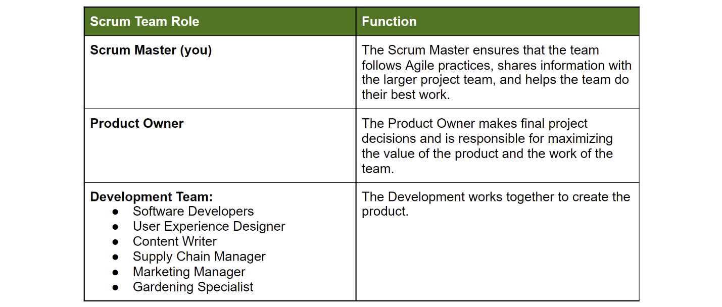

Virtual Verde release plan emails
Email 1:

From: content_manager@officegreen.com
Date: March 25
Subject: Tutorial videos and help pages completed

Dear Scrum Master,

Good news! The content team had a major project get reassigned, which freed up our team to work on tasks for Virtual Verde. We were able to finish the June seasonal care emails ahead of schedule. We’re now working on the content for July-November emails and expect them to be done before Release 2.

Best,
Content Manager

Consider your options and make a plan:

Q. Does the update require your team to take action? If so, what are some possible options to address the update?
- [Answer]
- [Answer]
- [Add more if necessary]

Q. Do you need to consult anyone to make a decision? If so, who?
- [Answer]
- [Answer]
- [Add more if necessary]

Q. Do you need additional information to help reach a decision? If so, what do you need to know?
- [Answer]
- [Answer]
- [Add more if necessary]

If you think a change to the release plan is needed, write an email to the Scrum team:

To: [Answer]
From: [Answer]
Subject: [Answer]

[Body]

[Email closing]

Email 2:

From: vendor_manager@officegreen.com
Date: April 10
Subject: New vendor management system issues

Dear Scrum Master,

Just wanted to flag for you: The new vendor management system/database the team created in an earlier Sprint is having some major technical issues. We’re getting our orders in, but for some reason the stock in the database isn’t matching what’s actually in the warehouse. And I’m losing invoices. Since things are up-and-running with customers, I’m concerned this is going to cause supply chain issues, as well as relationship issues with our vendors. Can you give me an estimate of when we can get it fixed?

Best,
Vendor Manager

Consider your options and make a plan:

Q. Does the update require your team to take action? If so, what are some possible options to address the update?
- [Answer]
- [Answer]
- [Add more if necessary]

Q. Do you need to consult anyone to make a decision? If so, who?
- [Answer]
- [Answer]
- [Add more if necessary]

Q. Do you need additional information to help reach a decision? If so, what do you need to know?
- [Answer]
- [Answer]
- [Add more if necessary]

If you think a change to the release plan is needed, write an email to the Scrum team:

To: [Answer]
From: [Answer]
Subject: [Answer]

[Body]

[Email closing]

Email 3:

From: vendor_manager@officegreen.com
Date: June 9
Subject: We lost our Bonsai supplier

Dear Scrum Master,

I just got a call that our Bonsai tree supplier will stop carrying Bonsai trees at the end of this month. They’re willing to replace our Bonsai orders with different plants, but I’m not sure what kind. I know that we’re only a few weeks away from the July release and that the Bonsai trees are an important part of that release. What are your thoughts?

Best,
Vendor Manager

Consider your options and make a plan:

Q. Does the update require your team to take action? If so, what are some possible options to address the update?
- [Answer]
- [Answer]
- [Add more if necessary]

Q. Do you need to consult anyone to make a decision? If so, who?
- [Answer]
- [Answer]
- [Add more if necessary]

Q. Do you need additional information to help reach a decision? If so, what do you need to know?
- [Answer]
- [Answer]
- [Add more if necessary]

If you think a change to the release plan is needed, write an email to the Scrum team:

To: [Answer]
From: [Answer]
Subject: [Answer]

[Body]

[Email closing]

